Credit Card Fraud Detection
1st author name¹, 2nd author name², 3rd Shivam Borse³
¹1st author email; ²2nd author email; ³3rd borseshivam01@gmail.com

Aim : Develop an efficient, real-time credit card fraud detection system that reduces false positives and accurately identifies fraudulent transactions by using advanced machine learning techniques

Objective :
- Minimize Fraudulent Transaction Losses: Develop a model that can quickly and accurately identify fraudulent transactions, preventing financial losses for both customers and financial institutions.

- Optimize Accuracy and Precision: Implement a model that balances high accuracy, precision, and recall in fraud detection, minimizing the rate of false positives (legitimate transactions wrongly flagged as fraud).

- Real-Time Fraud Detection: Create a system that can process and analyze transaction data in real-time, ensuring quick responses to potentially fraudulent activities.

- Introduction :

In today’s world, we are on the express train to a cashless society. According to the World Payments Report, in 2016 total non-cash transactions increased by 10.1% from 2015 for a total of 482.6 billion transactions! That’s huge! Also, it’s expected that in future years there will be a steady growth of non-cash transactions as shown below:
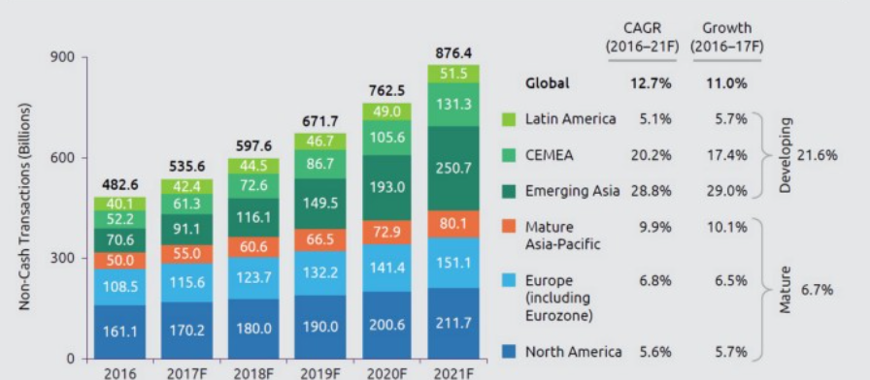

Now, while this might be exciting news, on the flip-side fraudulent transactions are on the rise as well. Even with EMV smart chips being implemented, we still have a very high amount of money lost from credit card fraud:
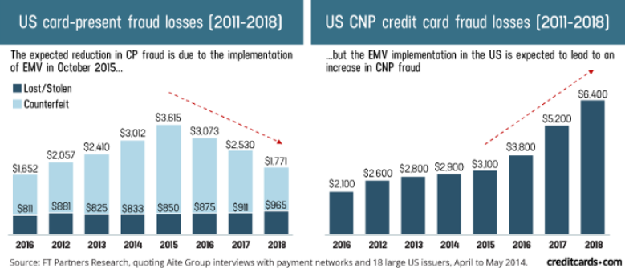
This is now becoming a serious problem since most of the time, a person who has become a victim of this fraud don't have any idea about what has happened until the very end. So in this project, what we have tried is to create a Web App for the detection of such type of frauds with the help of Machine Learning. In the following sections, we will be explaining about the creation and importance of both a good Machine Learning model and the Web App.

- Model Training :

- Understanding the data and related constraints :
The data for this project is very unbalanced due to the fact that number of cases of Fraud transactions are very low in comparison to number of cases of Valid transactions makes the model training a bit hectic. Because if we consider "classification accuracy" as the metric for training, we won't be getting the perfect view of how much our model is learning, because the classification accuray is derived as: classification_accuracy = No. of correct predictions/No. of labels So, now, consider the fact that if our data have 98% of the values to be valid while only 2% to be frauds, if our model predicts all values to be valid, it will eventually achieve 98% accuracy at the end of the day, but the model will be an absolute wastage. For this reason, we use a different type of metric which will give us much more important information about what our model has learned. Actually, what we do is we print the classification matrix for our model predictions and then we judge our model based on that matrix. Precision and Recall are two of the derivatives of a confusion matrix, we will consider them both though, but only Recall will come in handy for us since high Recall will ensure that no fraud value gets detected to be a valid one. Also, Precision do the vice-versa. We will need to find the best threshold where the Precision-Recall tradeoff will give us the best results

- Preprocessing data :

Balancing Data the data is very imbalanced, we will be using some Undersampling and Oversampling techniques. As the name suggests, Undersampling is use to reduce the samples from majority class and Oversampling is used to increase the samples from minority class. This way, we can achieve some balancing of the data.
Scaling features Now, even though almost all of the features are dimensionally reduced using some dimensionality reduction technique, two of the features are in their original form. Time and Amount are the two features which we will be scaling in order to make our model learn features correctly.
Splitting the data Now, since we needed to save some entries from the data for our testing purpose, we will now be splitting the data into two parts, namely, train and test .
Miscellaneous Now, other than the above three techniques, we did some Exploratory Data Analysis[EDA] on the data, we get the idea of outliers in the data, feature importance etc. by doing this amazing part. One can find the EDA in the notebook itself.

- Model Architecture :

We will be using a Logistic Regression classifier for our project. A logistic Regression model is used to predict the probability of a certain class or event existing. We then decide the class from which the entry belongs by using a threshold value. This threshold value is decided by manipulating the Precision-Recall tradeoff as explained above.
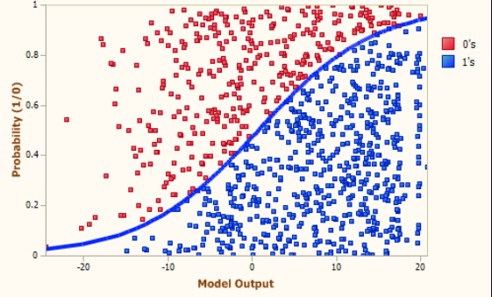
Also, while training, we used GridSearchCV to find the best possible parameters for our model so that it can squeeze the maximum amount of important information out of the data.

- Post Training :

After a model gets trained, this is our duty to understand the results and ensure its reliability because this will be used for a generalization purpose. Let's now see the inference results we got after training by using the following confusion matrix from our training notebook:

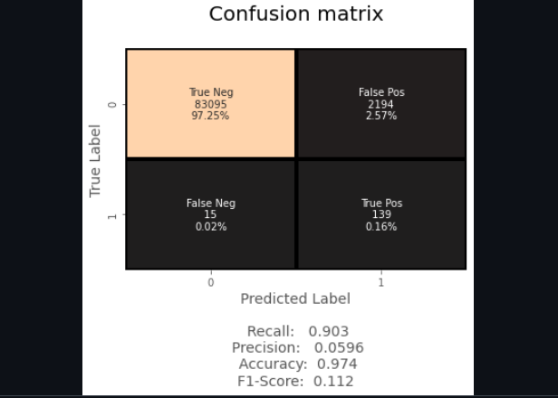

- How to Predict using the Web App :

Home The home page of the web app will look something like this:

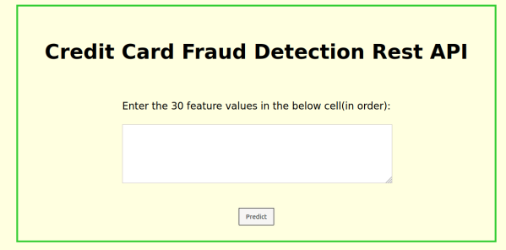

What we need to do is just copy the data entry which we want to predict into the box, this box will take 30 float/integer values as input, with at least one whitespace dividing them

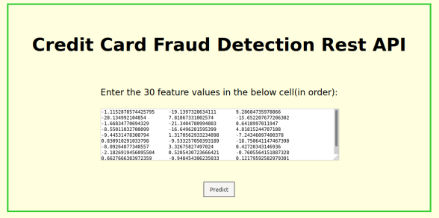

Now, we are ready to predict if the transaction entry we provided is fraud or not. If the transaction will be a fraud transaction, the screen will be something like this:

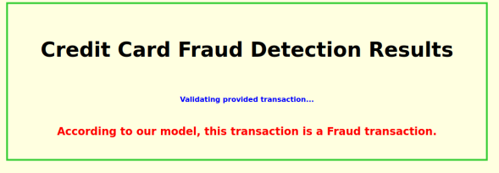

And if our transaction is not fraud, it will look something like the following:

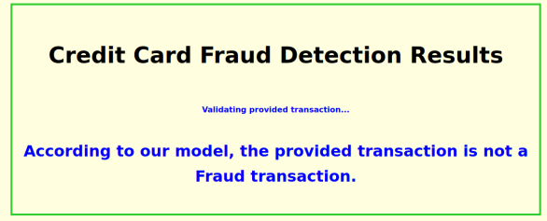

- Conclusions :
Credit Card is a great tool to pay money easily, but as with all the other monetary payment tools, reliability is a issue here too as it is subjected to breach and other frauds. To encounter this problem, a solution is needed to identify the patterns in the transactions and identify the ones which are fraud, so that finding such transactions beforehand in future will be very easy.
Machine Learning is a great tool to do this work since Machine Learning helps us in finding patterns in the data. Machine Learning can help producing great results if provided enough amount of data. Also, with further advances in the technology, Machine Learning too will advance with time, it will be easy for a person to predict if a transaction is fraud or not much more accurately with the advances.

- References :

- https://github.com/shivam1750/ccfd
- 25 February 2022 , A machine learning based credit card fraud detection using the GA algorithm for feature selection , Springer
- “Credit Card Fraud Detection: A Novel Approach Using Aggregation Strategy and Feedback Mechanism.”
- Mohammed, Emad, and Behrouz Far. “Supervised Machine Learning Algorithms for Credit Card Fraudulent Transaction Detection: A Comparative Study.” IEEE Annals of the History of Computing, IEEE, 1 July 2018,
- Pumsirirat, A. and Yan, L. (2018). Credit Card Fraud Detection using Deep Learning based on Auto-Encoder and Restricted Boltzmann Machine. International Journal of Advanced Computer Science and Applications, 9(1).
- “Credit Card Fraud Detection Using AdaBoost and Majority Voting.”
- Melo-Acosta, German E., et al. “Fraud Detection in Big Data Using Supervised and Semi-Supervised Learning Techniques.” 2017 IEEE Colombian Conference on Communications and Computing (COLCOM), 2017,
- Credit Card Fraud Detection Using State-of-the-Art Machine Learning and Deep Learning Algorithms , 2022, IEEE Access
- Detection of fraudulent transactions in credit card using machine learning Algorithms

